**Exhibit “B”:**

**Development Requirements for Planned Development – Industrial District (PD-I)**

**Carrabba Industrial Park**

**SECTION 1: GENERAL PURPOSE AND DESCRIPTION**

The development requirements for the Planned Development – Industrial District (PD-I) for the Carrabba Industrial Park, hereinafter called “the district” or “this district”, are intended to help guide land use planning and physical development on the subject property. Many properties in this 250+-acre industrial park have been developing since before the City of Bryan first adopted zoning regulations in 1989. It is the intent of these requirements to recognize the long history of industrial development on the property, and help facilitate appropriate future development in the older, newer, and yet-to-be-developed portions of the park. These requirements establish development standards that provide for attractive modern industrial development along Texas State Highway 21, one of the City’s major gateway corridors, strengthen the area’s economy, and promote the general welfare of the community.

These requirements, at times, will distinguish between development requirements for land in Phases 11 – 15 of the Carrabba Industrial Park Subdivision (except Phase 13A) and all other land in this PD-I District. In this context, Phases 11 – 15 of the Carrabba Industrial Park Subdivision, or any reference to a subdivision phase thereof, except Phase 13A, shall refer to those 99.4 acres out of the Stephen F. Austin League adjoining the north side of East State Highway 21, between Gooseneck Drive and Marino Road, as shown on a master plan that was approved by the City of Bryan’s Planning and Zoning Commission on August 18, 2018 (case no. MP18-06). Land located in Carrabba Industrial Park – Phase 13A is not part of this PD-I District.

**Section 2: Definitions**

1. Words, terms and phrases in this Development Plan shall have the meanings ascribed to them in Bryan Code of Ordinances Chapter 130, Zoning.
2. In this specific context, the term "permitted" shall mean all land uses permitted by right within the zoning classification specified, as well as other land uses defined and described in the Zoning Ordinance of the City of Bryan as being permitted with approval of a Conditional Use Permit. Said uses permitted with approval of a Conditional Use Permit shall be subject to development review procedures of the City of Bryan Zoning Ordinance described for Conditional Use Permits.
3. Words, terms, and phrases that are not expressly defined in these development requirements and/or in the Bryan Code of Ordinances have their ordinary dictionary meanings, based on the latest edition of Merriam-Webster’s Unabridged Dictionary. When not inconsistent within the context, words used in the present tense include the future; words used in the singular number include the plural, and words used in the plural number include the singular.

**SECTION 3: LAND USES**

1. The continued use of land permitted within in this Planned Development – Industrial District (PD-I) shall be limited to uses generally permitted in the Industrial (I) zoning district, with the following additions and exceptions:
   1. The following land uses shall also be permitted in this district:
      1. manufactured home sales and display
      2. Stable – Commercial
      3. Rodeo Grounds
      4. Portable/small commercial structures – Permanent
      5. Portable/small commercial structures – Seasonal
      6. Private utility company with outdoor storage
   2. The following land uses shall not be permitted in this district:
      1. Adult entertainment
      2. Gaming establishments
      3. Nightclub/tavern
      4. Wrecking yards (junkyards)
2. The continued use of land permitted on 35.24 acres of land within this PD-I District, being Carrabba Industrial Park – Phases 13B and 14, or any part thereof, shall be limited to land uses generally permitted in the Commercial District (C-3). The additions of Section 3.1.a. above shall not apply.

**Section 4: Land and Site Development**

1. Physical development in this PD-I District shall comply with development standards and limitations of the City of Bryan Code of Ordinances that generally apply to development on properties zoned Industrial District (I), subject to additions, modifications, or exceptions described herein.
2. Physical development on 35.24 acres of land within this PD-I District, being Carrabba Industrial Park – Phases 13B and 14, or any part thereof, shall comply with development standards and limitations of the City of Bryan Code of Ordinances that generally apply to development on properties zoned Commercial District (C-3), subject to additions, modifications, or exceptions described herein.
3. The following additional standards, modifications, or exceptions shall be applicable to the physical development and continued use of land and buildings in this PD-I District:
   1. Access and Off-Street Parking.
4. Carrabba Industrial Park Subdivision - Phases 11 – 15.
   * 1. Off-street parking requirements shall comply with access and off-street parking standards of the City of Bryan Code of Ordinances that generally apply to development on properties zoned Industrial District (I).
   1. All Other Land in this PD-I District.
      1. On land where no structure or use existed on the date that this PD-I District was established, developments shall comply with access and off-street parking standards of the City of Bryan Code of Ordinances that generally apply to development on properties zoned Industrial District (I).
      2. Where a structure or use existed on the date that this PD-I District was established, and a change of owner, use, or tenant occurs, then only developments that require off-street parking for customers shall comply with access and off-street parking standards of the City of Bryan Code of Ordinances that generally apply to development on properties zoned Industrial District (I).
      3. When required per Section 4.a.ii.b) above, off-street parking for customers shall be provided for at a ratio of one (1) space per 400 square feet of gross floor area.
      4. When required per Section 4.a.ii.b) above, off-street parking, driveway and maneuvering areas shall be paved with an all-weather surface of asphalt or concrete.
   2. Screening Fence Standards.
5. Carrabba Industrial Park Subdivision - Phases 13B and 14 (35.24 acres of land).
6. Screening fence standards of the City of Bryan Code of Ordinances that generally apply to development on properties zoned Commercial District (C-3), shall apply. Industrial outdoor storage shall not be allowed on these 35.24 acres of land.
7. All Other Land in this PD-I District.
8. No screening fences shall be required along internal property lines.
9. No screening fences shall be required for industrial outdoor storage.

1. Screening fences, where required by screening fence standards of the City of Bryan Code of Ordinances that generally apply to development on properties zoned Industrial District (I), shall be applicable only along exterior lot lines where land in this PD-I District abuts land that is located outside of this district but within the Bryan City limits.
2. Dumpster pads shall be enclosed with a six-foot tall fence on three sides with the fourth side remaining open for access or being fitted with a gate matching the other three sides. Materials approved for dumpster pad fencing shall include chain-link fencing.
   1. Buffer Area Requirements.
      1. No non-development buffer area requirements shall apply to any land in this district, notwithstanding any future changes to zoning classifications on abutting properties.
   2. Landscaping.
3. Carrabba Industrial Park Subdivision - Phases 11, 12, and 15 (64.14 acres of land).
4. Landscaping requirements shall comply with standards of the City of Bryan Code of Ordinances that generally apply to development on properties zoned Industrial District (I), except that only an area equal to 7.5 percent of the developed area (building site) shall be required to be landscaped. The developed area shall include the main structure, any accessory structure(s), and parking lots.
5. For the purposes of this section, outdoor storage areas and equipment lots shall be excluded from the calculation of required landscaping.
6. Required on-site landscaping shall be installed within 50 feet of a public right-of-way. If a site abuts more than one public right-of-way, then landscaping shall be evenly distributed along all public rights-of-way.
7. No additional landscape screening of outdoor parking areas shall be required where such areas are located within 30 feet of a street right-of-way.
8. Carrabba Industrial Park Subdivision - Phases 13B and 14 (35.24 acres of land).
9. Landscaping requirements shall comply with standards of the City of Bryan Code of Ordinances that generally apply to development on properties zoned Commercial District (C-3), except that only an area equal to 7.5 percent of the developed area (building site) shall be required to be landscaped.
10. All Other Land in this PD-I District.
11. No new landscaping shall be required. Preservation of existing and/or replacement of landscaping dead landscaping is encouraged.
12. Landscape Reserve Areas.
    1. There shall be two (2) landscape reserve areas in this district:
       1. one (1) at the north corner of East State Highway 21 and Gooseneck Drive (“Sign 1”); and
       2. one (1) at the north corner of East State Highway 21 and North Thornberry Drive (“Sign 2”).
    2. Landscape reserve area “Sign 1” shall provide a minimum of 9,450 SF of landscaping.
    3. Landscape reserve area “Sign 2” shall provide a minimum of 16,350 SF of landscaping.
    4. Both landscape reserve areas shall generally be located in the locations and conform to the planting schedules shown on attached Exhibit “B-1”.
    5. Signage.
13. Off-premise signs.
    1. Up to two (2) off-premise signs shall be permitted on land within this district: one (1) at the north corner of East State Highway 21 and Gooseneck Drive; and one (1) at the north corner of East State Highway 21 and North Thornberry Drive.
    2. Any such off-premise sign shall:
       1. be no more than sixteen (16) feet in height; and
       2. have no more than ninety-six (96) square feet of total sign area; and
       3. shall be set back at least 25 feet from all property lines; and
       4. comply with the design detail shown on attached Exhibits “B-1” and “B-2”*.*
14. On-premise signs.
    1. On-premise freestanding signage shall not be allowed.
    2. On-premise freestanding signage that existed on the date that this PD-I District was established shall be considered legally non-conforming.

**SECTION 4: SUBDIVISION OF LAND**

1. The subdivision of land in this PD-I District shall be in accordance with Chapter 110, Subdivisions, of the City of Bryan Code of Ordinances, with the following exceptions to ordinary standards:
   1. Standards for Subdivision Design – Electrical Service
2. Carrabba Industrial Park Subdivision - Phases 13B - 15 (60.86 acres of land).
3. All electrical distribution lines shall be installed underground in accordance with the Bryan Texas Utilities (BTU) Conduit Installation Guidelines in effect at the time of development.
4. All Other Land in this PD-I District.
5. Electrical distribution lines may be extended and installed above ground to buildings along the rear and sides under the following circumstances:
   1. when existing above ground electrical distribution lines are present on the abutting property; and
   2. when the property does not have any frontage along North Thornberry Drive.
6. No above-ground electrical distribution lines shall be located along or within the public rights-of-way at the front of properties.

**Exhibit “B-1”:**

**Carrabba Industrial Park Landscape Reserve Areas**

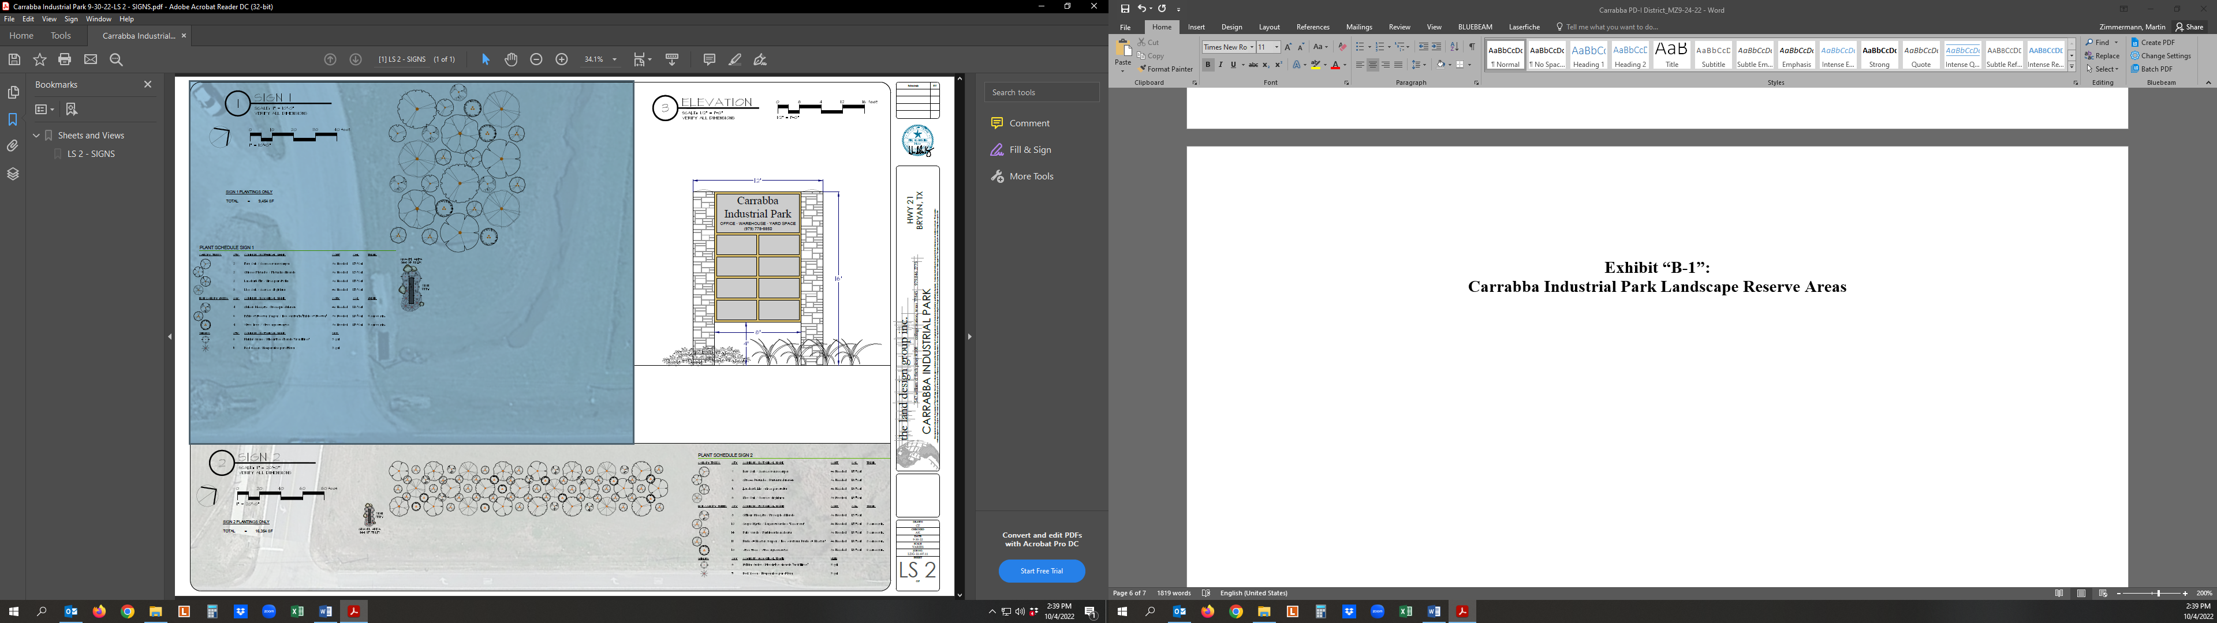

**Detail Landscape Reserve Area “SIGN 1”:**

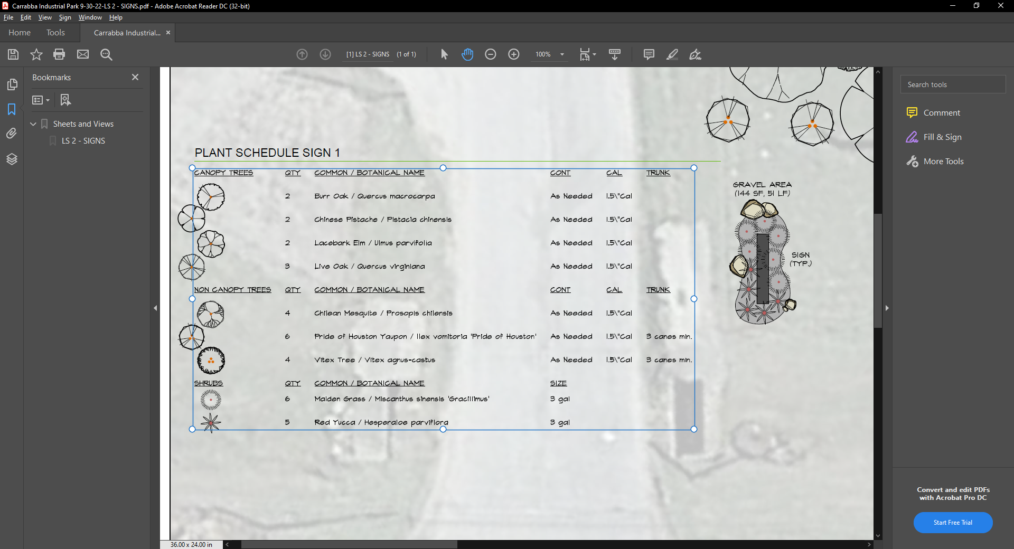

**Detail Landscape Reserve Area “SIGN 2”:**

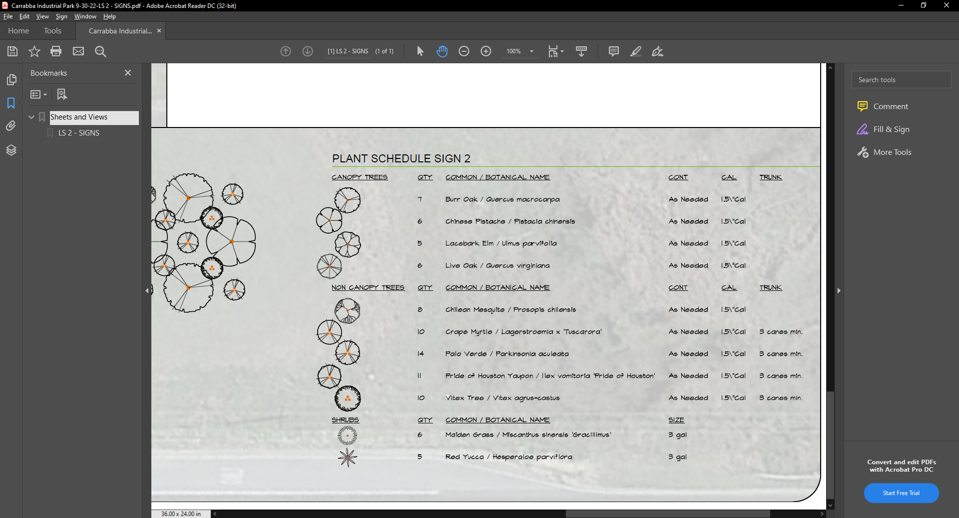**Exhibit “B-2”:**

**Carrabba Industrial Park Off-Premise Signage**

